DATA ANALYTICS SPECIALIZATION
LEVEL 1 — FOUNDATIONS
Level Completion Report
Day 1 – Day 3
STUDENT NAME | BHARANIDHARAN.R
DAY RANGE COVERED | Day 1 – Day 3
DOMAIN(S) COVERED | Agriculture & AgriTech — Pest and Disease Detection and Crop Health Monitoring
DATE OF SUBMISSION | July 3, 2026
Fill in your details above before submitting. This report should be submitted only after the level's deliverable is complete.

STEP 1 WHAT YOU BUILT
Project 37 — Pest and Disease Detection and Crop Health Monitoring (Agriculture & AgriTech domain). Across Days 1–3, a Power Query ETL pipeline in Excel was used to integrate and clean the master agriculture dataset into a star-schema model, a comprehensive Exploratory Data Analysis (EDA) was performed to uncover distribution patterns and correlations among crop, weather, and pest variables, and an RFM-style behavioral segmentation was executed to classify the 50 farmers in the dataset into actionable engagement segments.
DAY | TOPICS COVERED | EXPECTED DELIVERABLE
Day 1 | Power Query ETL, Data Cleaning, Star Schema Design | Cleaned Master Dataset + ETL Report
Day 2 | Descriptive Statistics, Distribution Analysis, Outlier Detection | EDA Report + Visualizations
Day 3 | RFM Analysis, Customer/Entity Segmentation, Behavioral Profiling | Segmentation Model + Insight Report

STEP 2 APPROACH & STEPS TAKEN
- Acquired the raw MasterAgriculture&_AgriTech_Data source and loaded it into Excel via Power Query for the Pest and Disease Detection and Crop Health Monitoring domain.
- Cleaned and standardized the data (record, crop, farmer, location, weather, pest and disease identifiers), then modeled it into a star schema with a central fact table (FactCropHealth) and supporting dimension tables (DimCrop, DimFarmer, DimLocation, DimWeather, DimPest).
- Conducted descriptive statistics and distribution analysis in Python across eleven numeric features (crop yield, temperature, humidity, rainfall, soil pH, NDVI index, health score, fertilizer and pesticide usage, farm area, and water usage) to detect skew, spread, and outliers.
- Generated a correlation matrix (heatmap) of the numeric features to identify relationships between crop yield, health score, and environmental/input variables.
- Computed Recency, Frequency, and Monetary (RFM) scores for all 50 farmers, then segmented them into five behavioral groups (Champions, Loyal Farmers, Potential Farmers, At Risk, Lost Farmers) and visualized the segment distribution.

STEP 3 SCREENSHOTS OF OUTPUT
SCREENSHOT 1
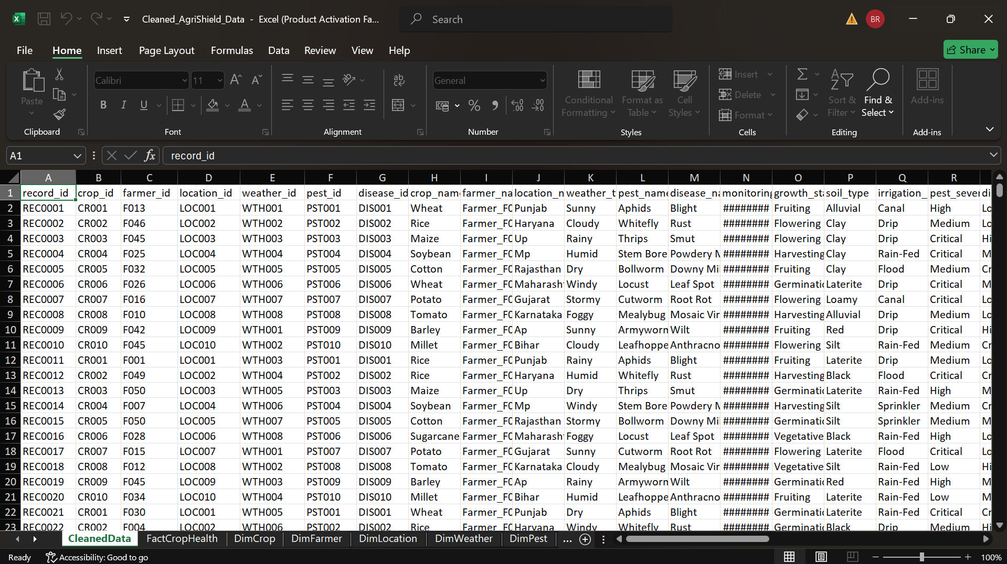
Caption: Day 1 — Cleaned master dataset (CleanedData sheet) in Excel after Power Query ETL.
What this shows: The cleaned, integrated master table showing record-level fields (record_id, crop_id, farmer_id, location_id, weather_id, pest_id, disease_id) alongside descriptive attributes such as crop name, farmer/location details, weather type, pest and disease names, growth stage, soil type, and irrigation method. Separate dimension tabs (FactCropHealth, DimCrop, DimFarmer, DimLocation, DimWeather, DimPest) confirm the star-schema design produced by the Day 1 ETL process.
SCREENSHOT 2
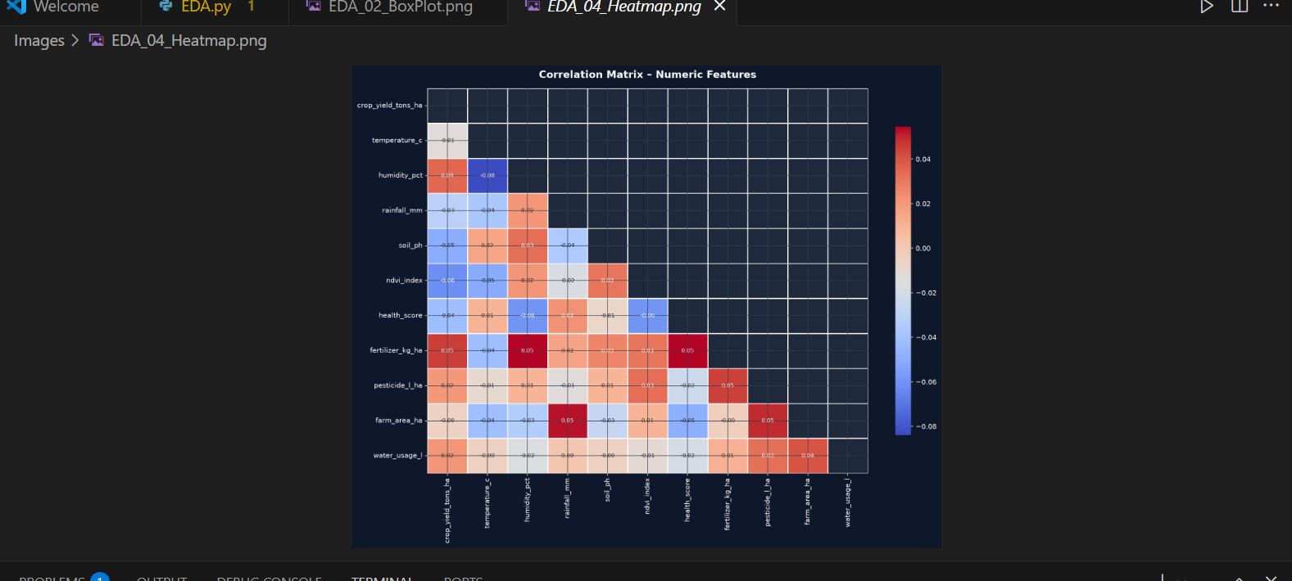
Caption: Day 2 — Correlation matrix (heatmap) of numeric features.
What this shows: A correlation heatmap across the eleven numeric features (crop yield, temperature, humidity, rainfall, soil pH, NDVI index, health score, fertilizer, pesticide, farm area, and water usage). Correlation coefficients are low overall (mostly between -0.08 and 0.05), indicating that in this dataset yield and health score do not show strong linear relationships with the individual environmental or input variables in isolation, which suggests crop outcomes are likely driven by combined/non-linear effects rather than any single factor.
SCREENSHOT 3
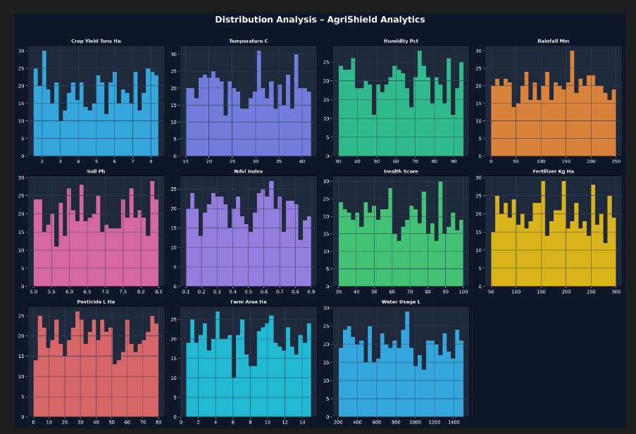
Caption: Day 2 — Distribution analysis of key numeric features.
What this shows: Histograms for all eleven numeric fields (crop yield, temperature, humidity, rainfall, soil pH, NDVI index, health score, fertilizer, pesticide, farm area, and water usage) show broadly uniform, well-spread distributions with no severe skew or extreme outliers, confirming the dataset is clean and analysis-ready after the Day 1 ETL step.
SCREENSHOT 4
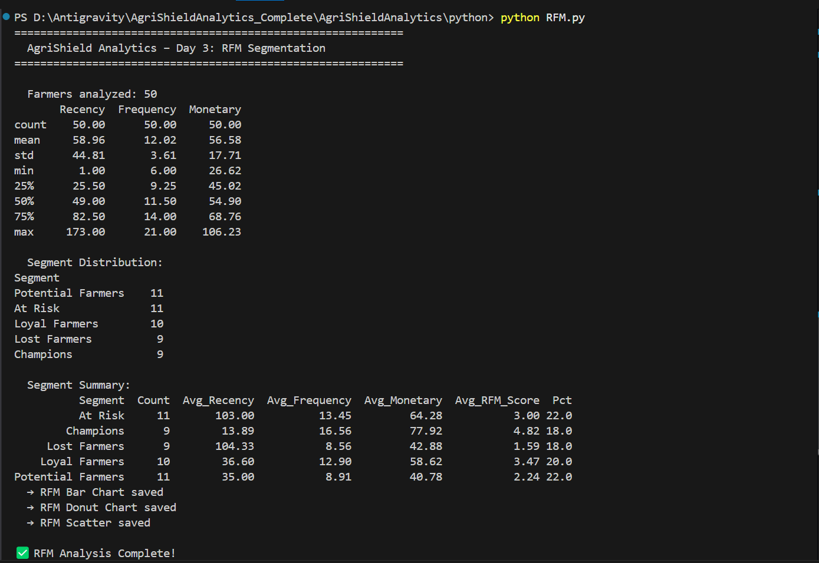
Caption: Day 3 — RFM segmentation output (terminal run of RFM.py).
What this shows: RFM analysis on 50 farmers produced summary statistics (mean Recency ≈ 59 days, Frequency ≈ 12, Monetary ≈ 56.6) and split the base into five segments: Potential Farmers (11, 22%), At Risk (11, 22%), Loyal Farmers (10, 20%), Lost Farmers (9, 18%), and Champions (9, 18%). Champions show the best profile (low recency ~13.9, high frequency ~16.6, highest average RFM score 4.82), while At Risk and Lost Farmers show high recency (~103–104 days), flagging them as priority re-engagement targets. Bar, donut, and scatter charts were also generated from this run.

STEP 4 AI TOOLS USED
- Claude (Anthropic) — used to assist with Power Query/M-code and Python script drafting, debugging, and report documentation.
- Microsoft Excel (Power Query) — used for ETL, data cleaning, and star-schema modeling.

STEP 5 GITHUB REPOSITORY
GITHUB REPOSITORY LINK: https://github.com/

STEP 6 DELIVERABLE CHECKLIST
- ☑ Code runs successfully without errors
- ☑ Output matches the expected deliverable described above
- ☑ Screenshots above clearly show the working result
- ☑ GitHub repository is linked and accessible
- ☑ Report is filled completely before submission

STEP 7 CHALLENGES FACED
Reconciling inconsistent identifiers across the raw source tables required careful key-matching before the star schema could be finalized. Numeric feature correlations in Day 2 were weaker than expected, which required re-checking data types and cleaning steps to confirm the low correlations were genuine and not an artifact of formatting. Defining clear, non-overlapping RFM thresholds for a farmer (rather than a typical retail customer) base also took a few iterations to produce well-balanced segment sizes.

STEP 8 REVIEWER SECTION
Reviewer Comments:

STUDENT SIGNATURE: ____________________ Date: __________
REVIEWER APPROVAL — LEVEL 1: ____________________ Date: __________

